IDNameDataBASE TEST DOCUMENTATION

30003389 – Kyer Potts

Table of Contents

Test Cases 1

Screenshot Evidence 2

1. 2

2. 2

3. 2

4 2

|  |  |  |  |
| --- | --- | --- | --- |
| Test ID | Description | Outcome | Evidence |
| 1 | Program Loads Successfully | Program loads with all GUI elements successfully | Refer to Screenshot 1. |
| 2 | Text field control receives user input | Control receives user input successfully | Refer to Screenshot 2 |
| 3 | Program retrieves data from database | Data retrieved successfully, data is displayed in messageText control | Refer to Screenshot 3 |
| 4 | Program displays “No ID Found” when incorrect ID format is entered to text field control | No ID found displayed in messageText control | Refer to Screenshot 4 |

# Test Cases

# Screenshot Evidence

### 1.

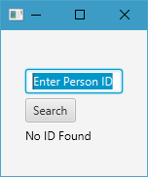

### 2.

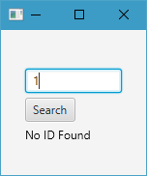

### 3.



### 4

